Section A – Violation Report

 | Operation |  |  |  |  |  |  |  |  |  | Projects
- Area Details
Plant |  |  |  |  |  |  | Department |  |  |  |  |  |  | Section
Date |  |  |  |  |  |  | Time |  |  |  |  |  |  | Location
- Business Partner Details
Name of Business Partner |  |  |  |  |  |  |  |  |  |  |  |  |  | Work Order No.
Name of Violator |  |  |  |  |  |  |  |  | Scrum ID |  |  |  |  | Designation
Name of Supervisor |  |  |  |  |  |  |  |  | Scrum ID
- Zero Tolerance (√ tick applicable) - Minimum Penalty of Rs. 1,00,000/- Applicable LSGR (√ tick applicable)
 |  |  |  |  |  |  |  |  |  | 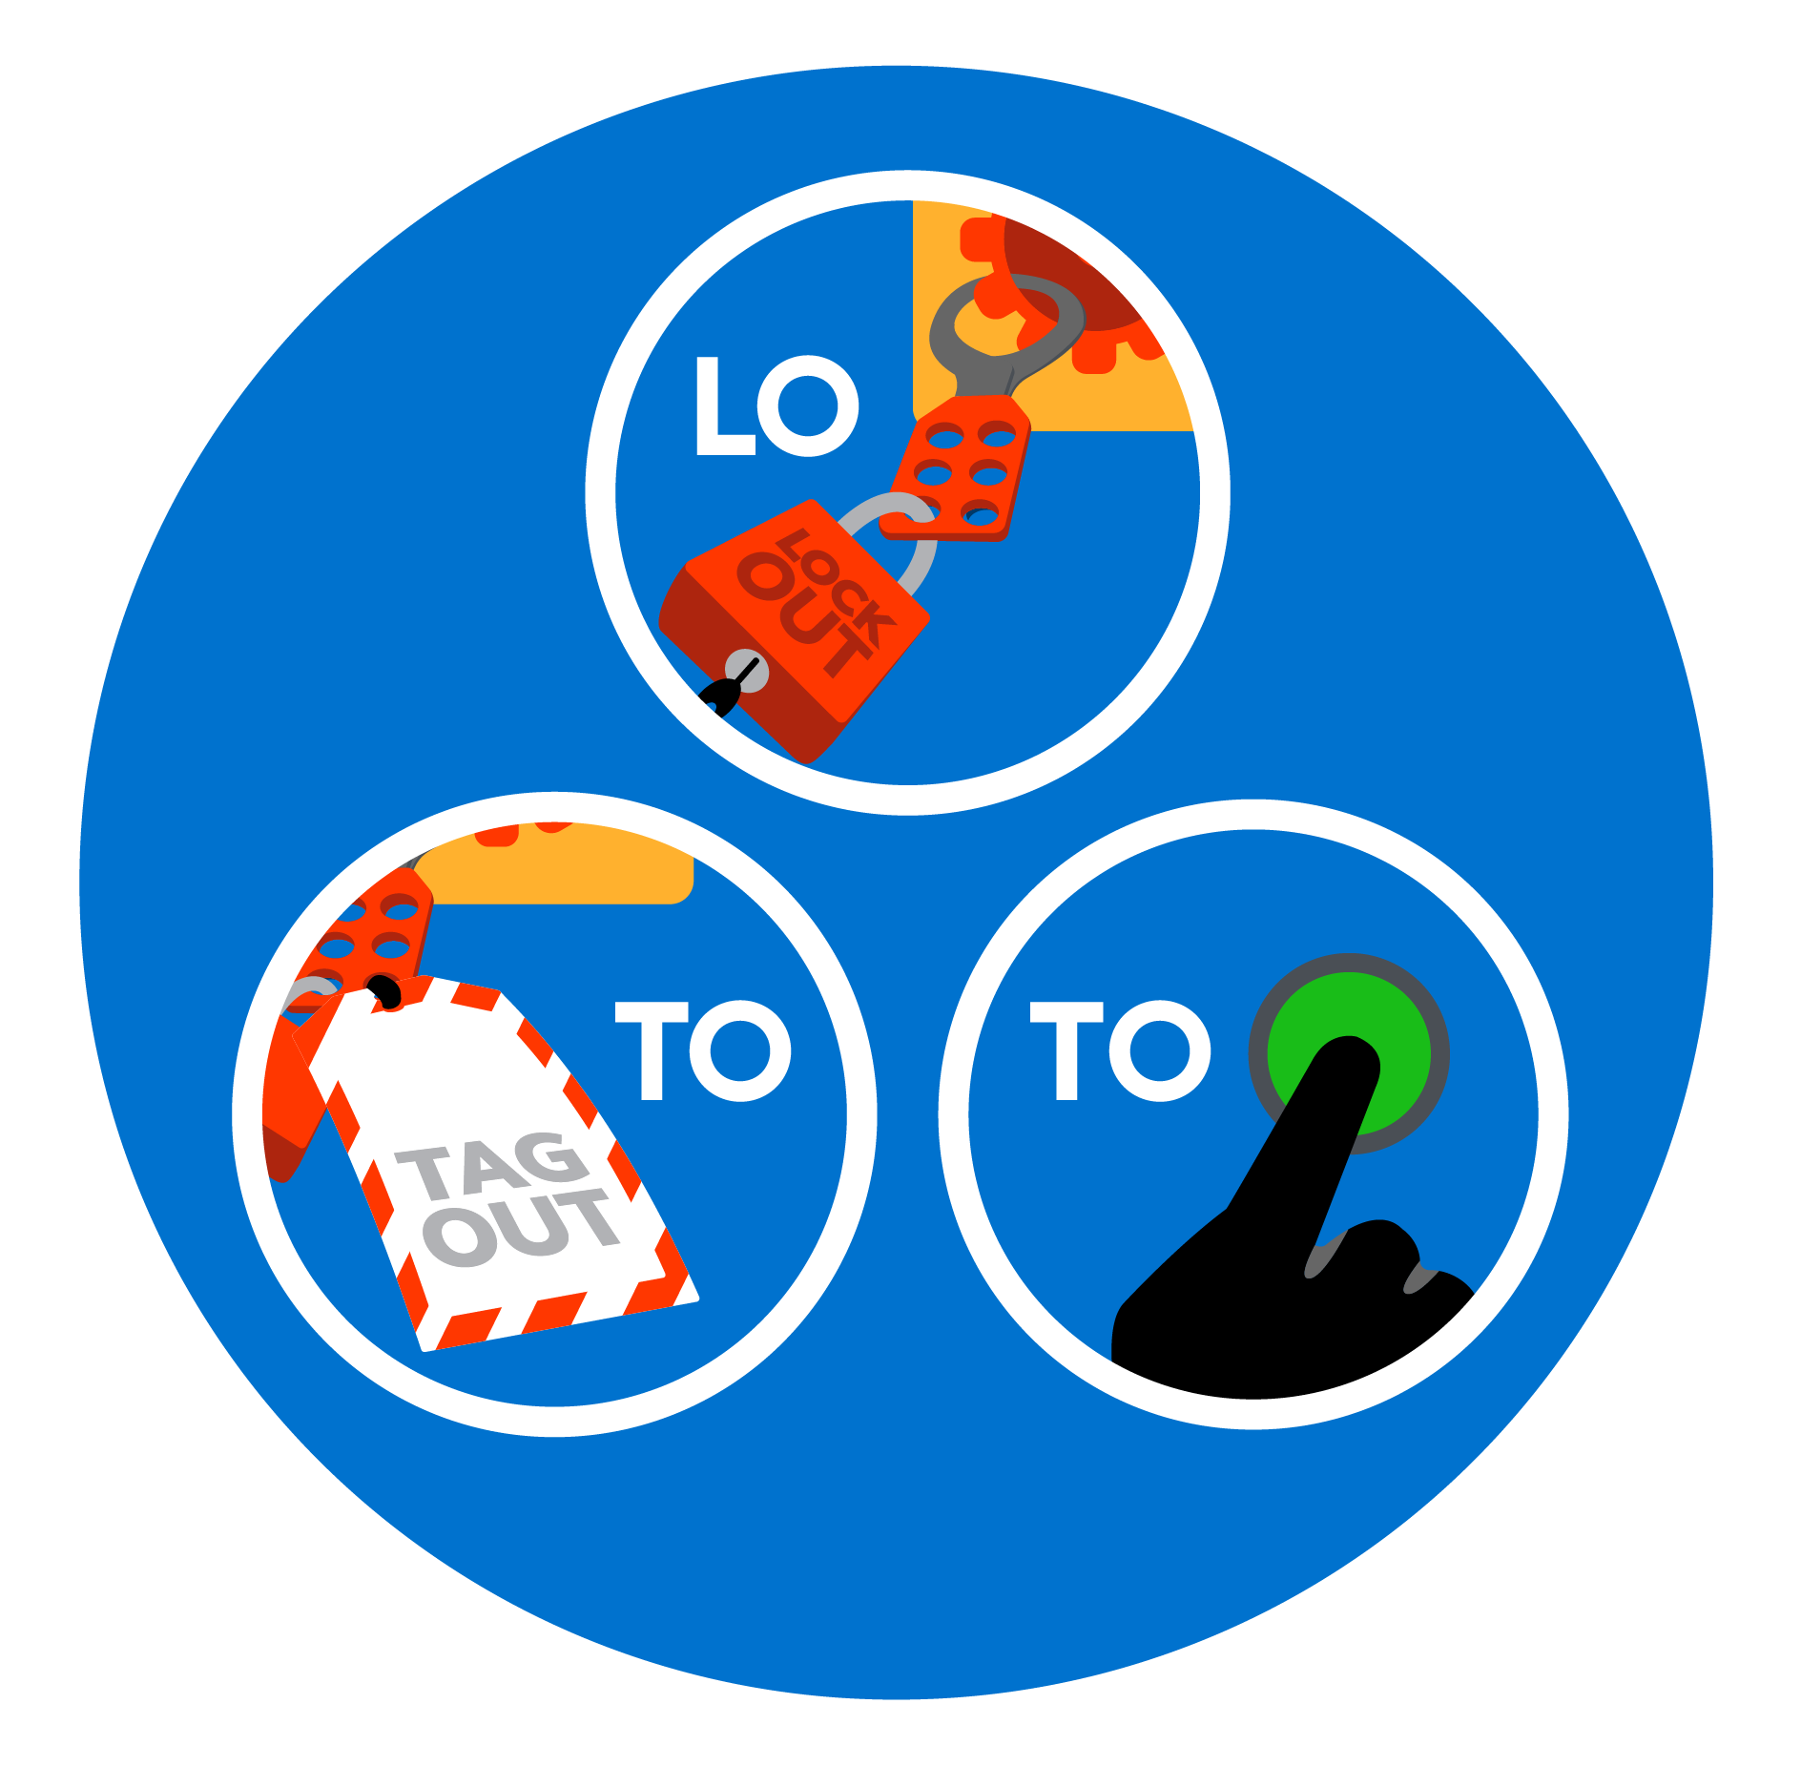 |  |  |  |  |  |  |  | 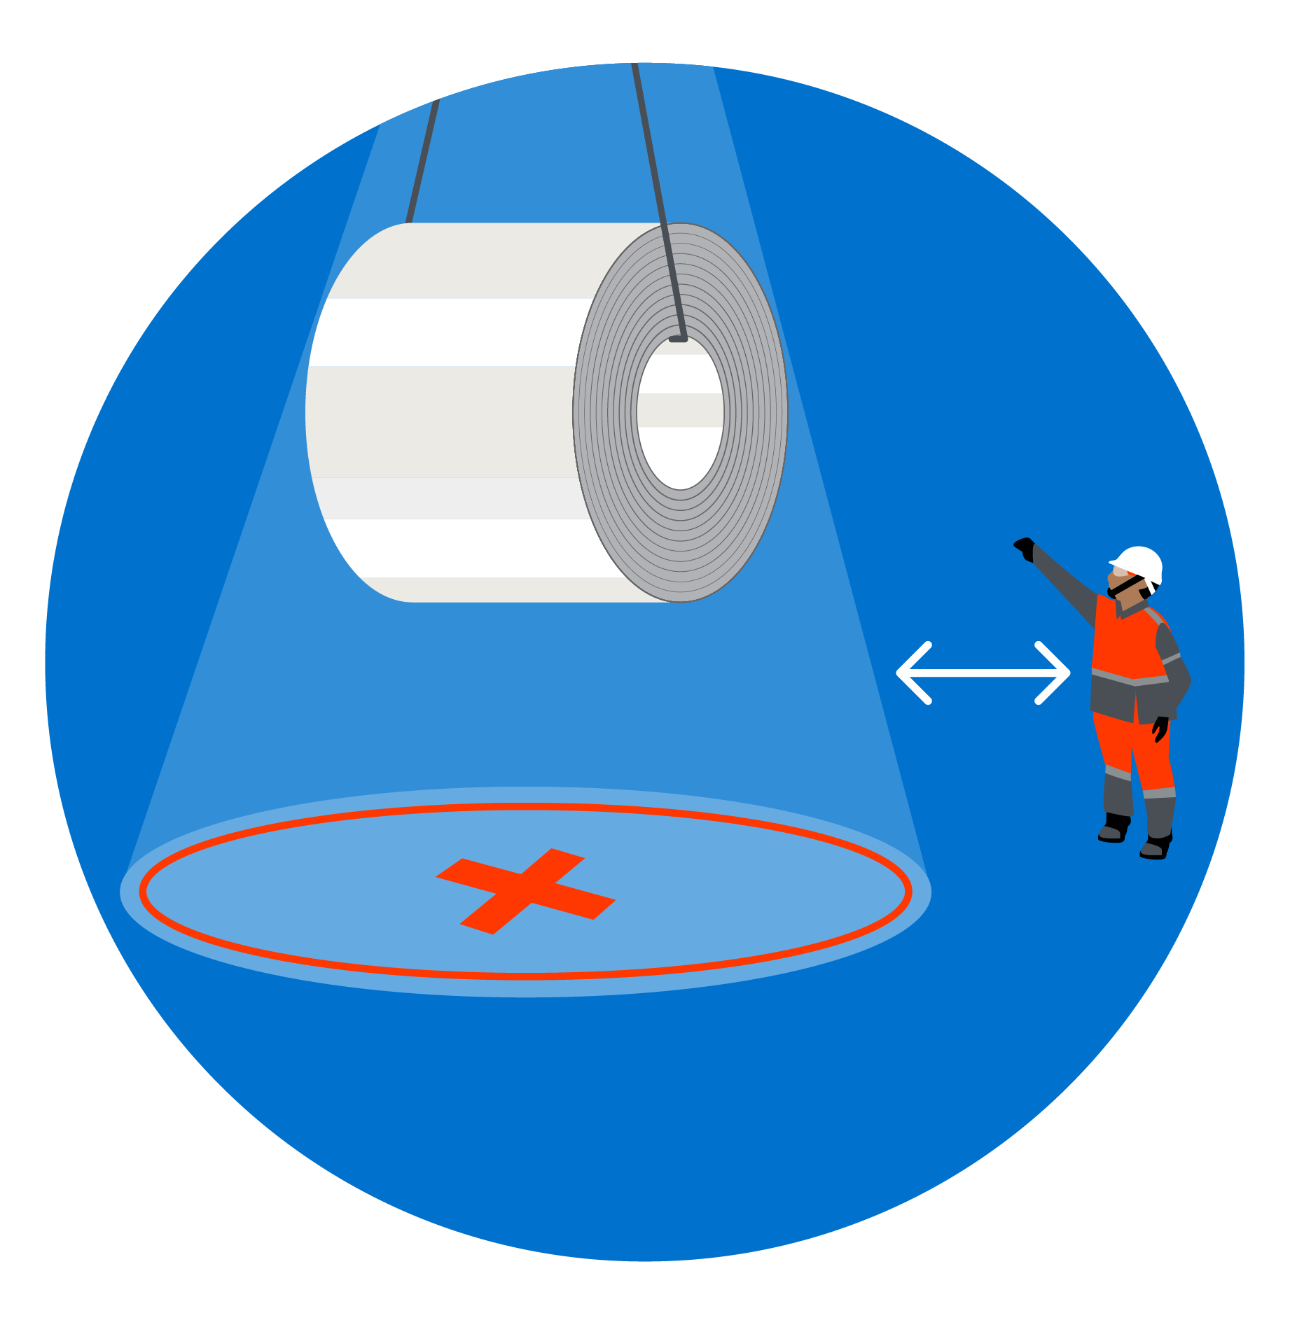
 |  | 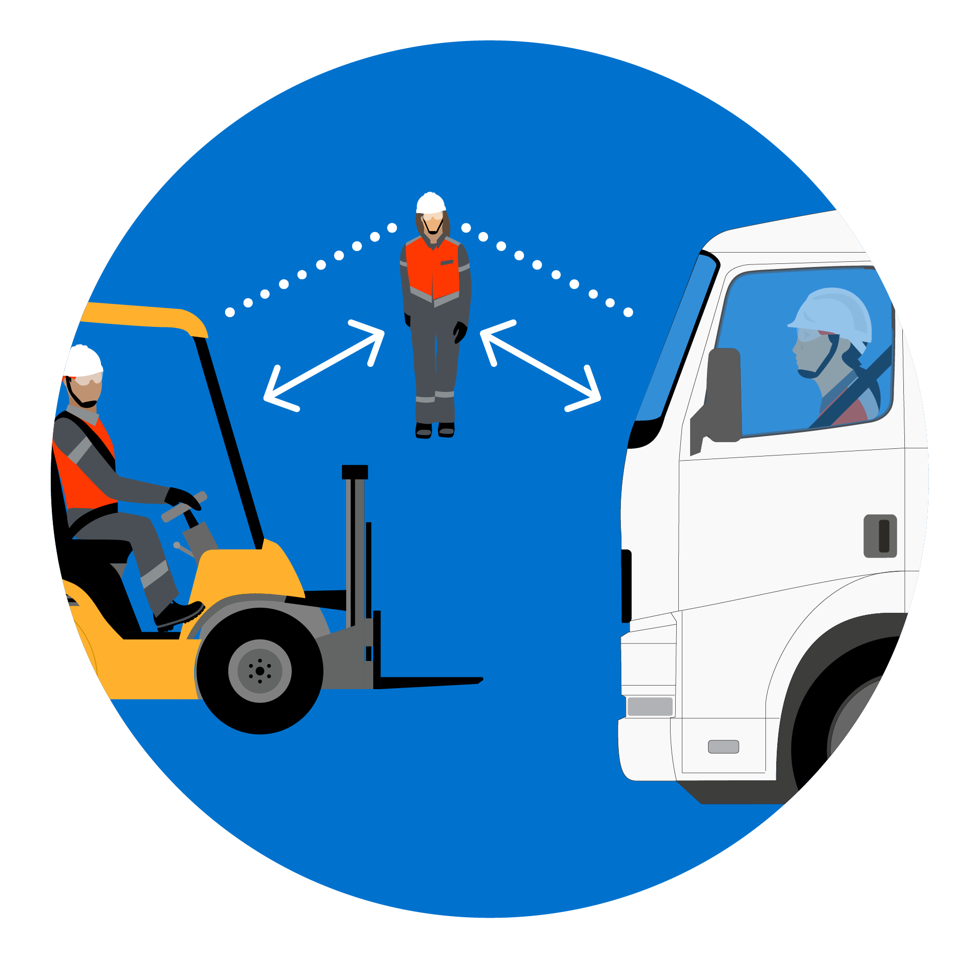 |  |  |  | 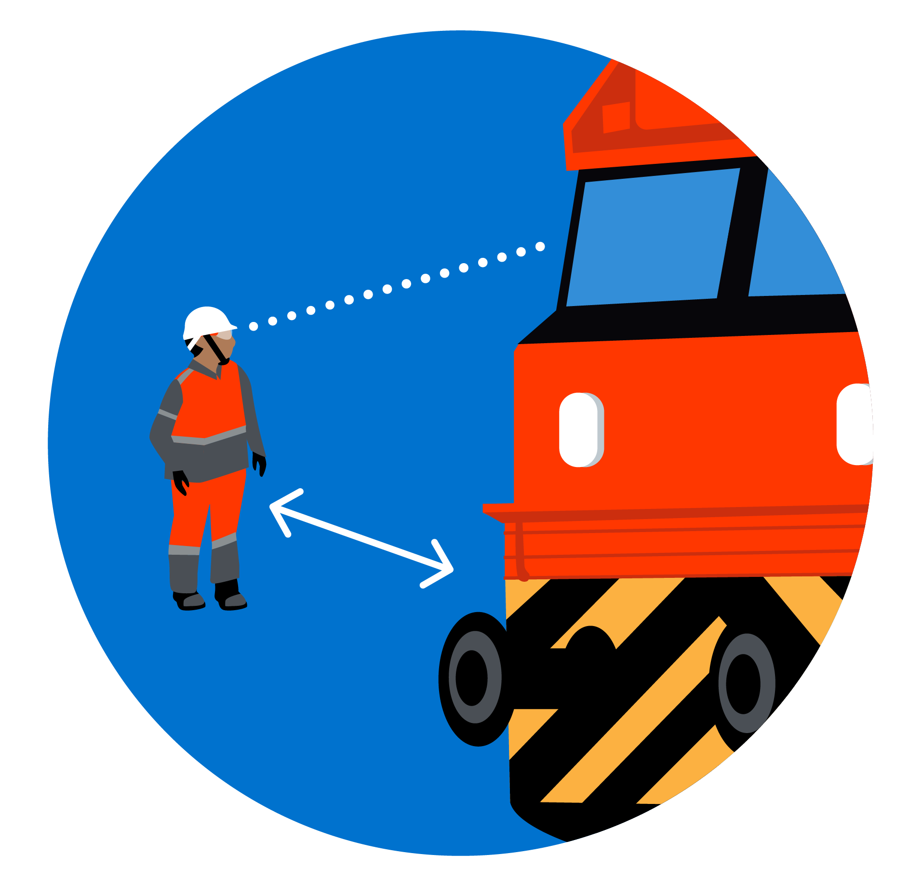 |  |  |  | 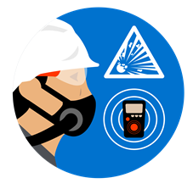 |  |  |  |  |  |  |  | 
- Applicable Killer Risk (√ tick applicable)
 |  | Fall from height |  |  |  | Crushed or rolled over by vehicle |  |  |  | Crushed by other mobile equipment |  |  | Crushed by moving machinery |  |  |  |  | Crushed by suspended load
 |  | Crushed by collapsing structure |  |  |  | Deep Excavation |  |  |  | Electrical Hazards
- Zero Tolerance (√ tick applicable) - Minimum Penalty of Rs. 1,00,000/-
 |  | Working without PTW /  Working by deviating PTW conditions |  |  |  | Work at height related violation |  |  |  | Confined space related violations |  |  | Electrical related violations |  |  |  |  | Engagement of non-validated person in skilled category of work
- Details of Violation
- Acceptance of Violation
Signature of Business Partner Engineer |  |  |  |  |  |  |  |  |  | Signature of AM/NS Engineer
Name of Business Partner Engineer |  |  |  |  |  |  |  |  |  | Name of AM/NS Engineer
Scrum ID of Business Partner Engineer |  |  |  |  |  |  |  |  |  | SAP ID of AM/NS Engineer
Date |  |  |  |  |  |  |  |  |  | Date

Section B – Recommondation of Penalty & Disciplinary actions

- Recommonded Action on Worker
- Recommonded Action on Supervisor / Engineer / Manager
- Penalty Recommondation Details
- Approvals
Recommonded By |  | Approved By
Signature |  | Signature
Name |  | Name
SAP ID |  | SAP ID
Designation | Section In-Charge -Safety / Safety Head | Designation | Section In-Chearge / Project Head
Date |  | Date

Note: Copy of approced violation report and penalty recommendation to be communicated to Purchase Department, PMC Team and Accounts / Finance Department for further actions in addition to respective HODs.

Accounts / Finance departments to confirm the processing of penalty once tmhe approved copy of penalty recommendation is received.

